Product Specification
Customer：
Supplier：Shenzhen Zhongke Century Technology Co.,Ltd
Product Name：Brushless DC Pump
Item：DC40M Series
Date：
Customer Confirmation：
确认  TEDTED BY | 审核  CHECKED BY | 批准  APPROVED BY | 承认章

The factory signature：
制作  MADE | 审核  CHECKED BY | 批准  APPROVED BY | 承认章

ADD:NO.4 building,fu'an 3th industrial area,dayang instrial zone,fuyong,baoan,ShenZhen
Mobile：18124127759 Email：dcpump@szzksj.com
TEL：0755—27811557 FaX：0755—27811571
Web：http://www.szzksj.com

Catalogue

一.Product Featuers 3
二.Range of Use 3
三.Basic Parameters 3
四.Special Function Description 3
五．Parameter Test Installation Diagram ---------------------4
六．Head-Flow Graph 5
七．Port Interface Diagram(Optional) 5
八.Outline Drawing 5
九.Assembly Drawing 7
十.Breakdown and Maintenance 8
十一．Matters Needing Attention 8

Make： Audit：

一.Product Featuers
1 | Product Name: | Zhongke Century DC40M pump |  |  |  | 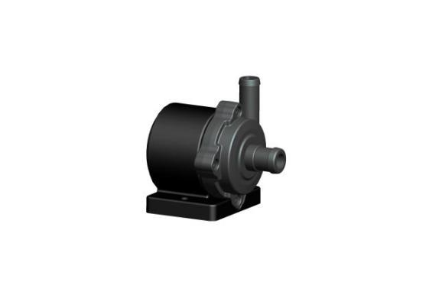
2 | Item： | DC40M Pump
3 | Weight： | 0.165kg
4 | Life： | 50000h
5 | Protection Level： | IP68
6 | Color： | Black
7 | Environment Protection Class： | Meet ROHS Environment requirements
8 | Frame Material： | PA66+30%GF
9 | Noise： | 9w≤30dB/5w≤25dB
10 | airtightness： | ≥0.5MPa
11 | Insulation Grade： | Level H（180°）
12 | Principle： | Centrifugal Pump
13 | Use： | Water heating mattress,arcola Etc.

二.Range of Use
1 | environment  temperature： | 0°—120°(3-phase,the controller is outside of pump.)
2 | Using Liquid ： | The oily medium,water and other liquid fluidity
3 | Using Liquid Temperature： | 0°—120°(3-phase,the controller is outside of pump.)
4 | Power type： | DC Power

三.Basic Parameters
1 | Rated Voltage： | 12V DC
2 | Voltage Range： | 8-14V |  |  |  | Pump can be used normally
3 | Rated Current： | 0.25A | 0.4A | 0.6A | 0.75A | ±5%
4 | Power： | 3W | 5W | 7W | 9W | ±5%
5 | Max Flow： | 350L/H | 410L/H | 480L/H | 530L/H | ±5%
6 | Max Head： | 1.5M | 2.5M | 3M | 3.5M | Head means the Max. vertical lifting height of water, the flow is 0L/MIN@max head
7 | Max Input Current： | 1A
Driven by 3-phase sensor-less control, soft start without impulse, speed adjustable by PWM <50-800HZ 3-5V.>，0-5V signal.

四.Special Function Description
1 | Locked rotor protection | When the pump rotor is stuck,it will stop working.
2 | Dry run protection | When there is not enough water in the gland cavity,pump will stop working.
3 | Overload Protection | When the voltage is unstable or exceed the rated power,pump will stop working
4 | The power supply reverse | The positive and negative poles of the power supply are reversed and the pump stops running,after correct reconnection,normal work.

五．Installation Diagram
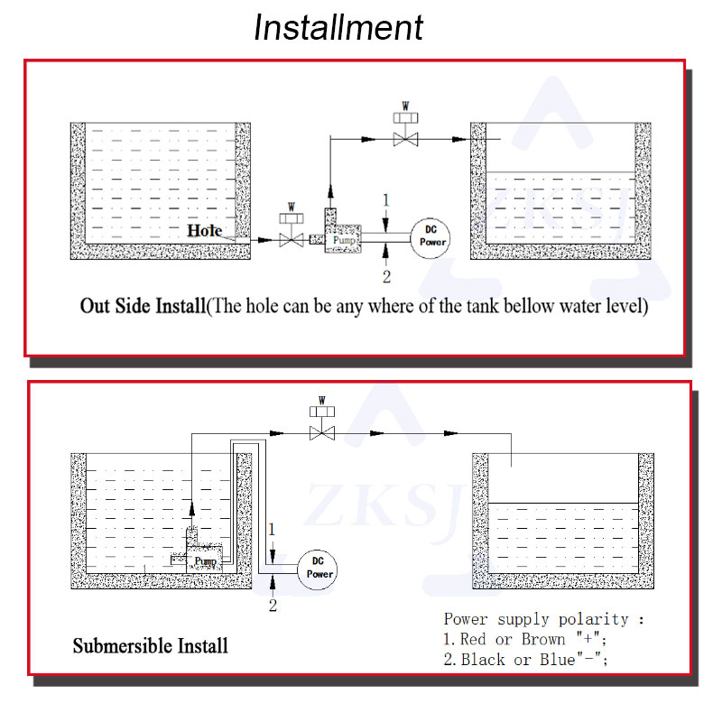
Attention：
This product does not have self-priming function. Therefore, when installing, it is necessary to ensure that there is enough water in the gland cavity, that is, the center position of the pump should be lower than the liquid level in the water tank to ensure the normal operation of the pump!

六．Head-Flow Graph

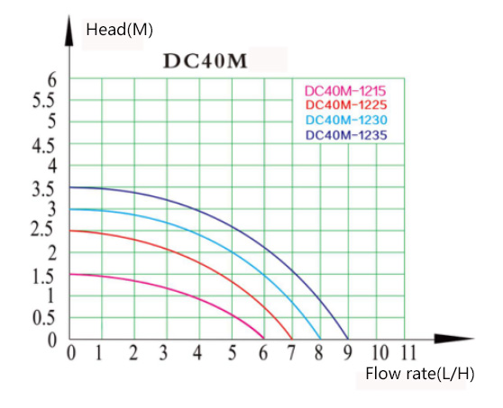

七．Port Interface Diagram(Optional)
Red wire：power positive(+) Black Wire：Power negative(-) Yellow Wire：
FG white wire：PWM

- Outline Drawing
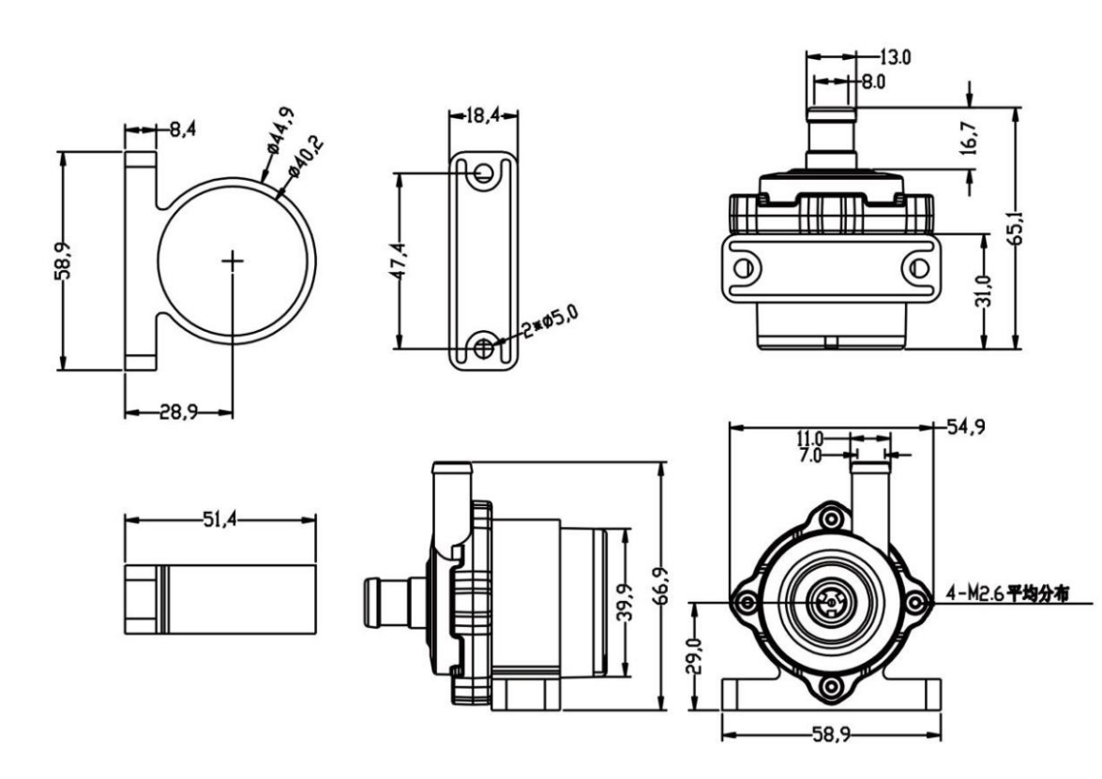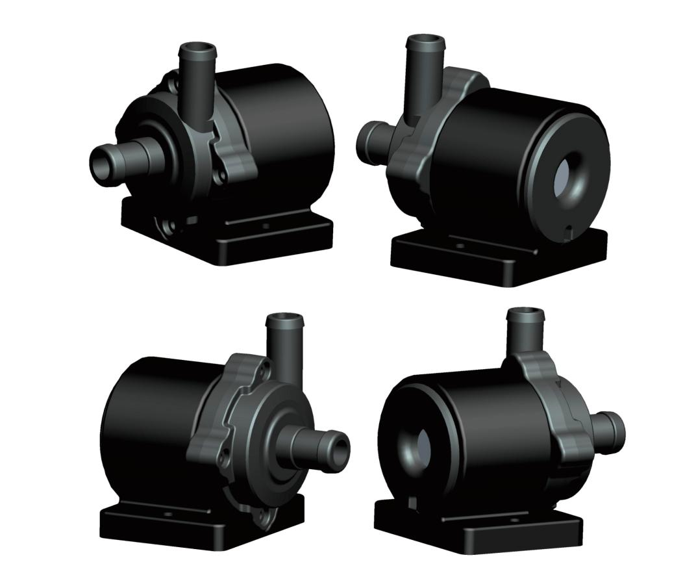

九．Assembly Drawing
Detail list of products and materials
No. | Part | Specification | qty | Material | No. | Part | Specification | Qty | Material
1 | Impeller cover | 40M | 1 | POM | 13 | Ceramic sharft | 29.5*2.27 | 1 | zirconia
2 | screw | 2.6*10 | 4 |  | 14 | Silicone base |  | 1 | Silicon
3 | Ceramic gasket | 7*2*2.32 | 1 | Zirconia | 15 | Ferrite rotor | 14.7*12.4*6 | 1 | Ferrite
4 | Three-phase insulation sleeve |  | 1 | PA66+30%FG | 16 | Ceramic shaft rubber sleeve | 3.5*7*2.3 | 1 | Silicon
5 | Three-phasa stator | 36*15.6*14 | 1 |  | 17 | Main body | 40M | 1 | PA66+30%FG
6 | Three-phase insulation sleeve |  | 1 | PA66+30%FG
7 | PCB | 33.4*9.4*1.5 | 1
8 | Back cover | 40M | 1 | PPA66+30%FG
9 | Gland | 40M | 1 | PA66+30%FG
10 | Ceramic shaft rubber sleeve | 3.5*7*2.3 | 1 | Silicon
11 | Waterproof ring | 32*28*2 | 1 | Silicon
12 | Graphite bushing | 20*3.5*2.3 | 1 | carbon fiber

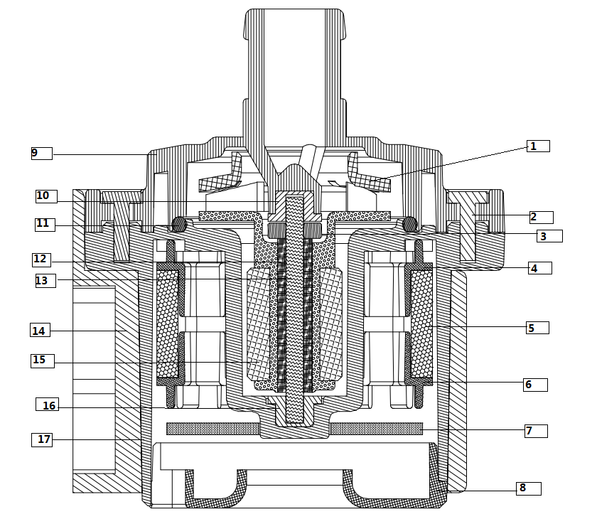

十．Breakdown and Maintenance

Breakdown and Maintenance
 | Failure | Reason | Method
1 | Large current,small flow | Impurities in the rotor | Filling the water from the water outlet to clean
2 | Rotor does not turn,the current sometimes large and sometimes small | The rotor is stuck due to foreign objects | Remove the jamming foreign objects
 | Does not turn,short circuit current | Control board damage | Replace the pump
 | No turn,no current | The power cord is not connected | Check if the connector or plug is connected right
3 | Loud noise | Impurities in the pump | Remove the impurities
 |  | Air in pump cannot discharge | Place the water outlet down, no air in the liquid
 |  | No liquid in the pump, dry pump | Input liquid

十一．Matters needing attention

Matters Needing Attention
1.It is strictly prohibited to use for liquid with more then 0.35mm impurities and magnatic particles
2.If pump a long time not using, it is better to have a certain liquid in the pump before powering on.。
3.It is not allowed to use the pump without any liquid for a long time。
4.It is necessary to prevent the pump from dust if a long time not using
5.Please confirm the connection before powering on, otherwise it may cause a malfunction.
6. When using in a low temperature environment, make sure that the liquid does not freeze or become very viscous.
7.If there is water at the pins of the connector, please clean and dry the pins before using。

ADD:NO.4 building,fu'an 3th industrial area,dayang instrial zone,fuyong,baoan,ShenZhen

Tel：0755-27811557

